# TUGAS

## SOAL

1. Berdasarkan gambar di bawah, buatlah tabel-tabel pada ERD menggunakan perintah SQL DDL.
2. Jawaban perintahnya, masukan ke dalam kolom jawaban di bawah!
3. Disimpan dan disubmit ke kantong tugas dalam format **.docx** atau **.pdf**

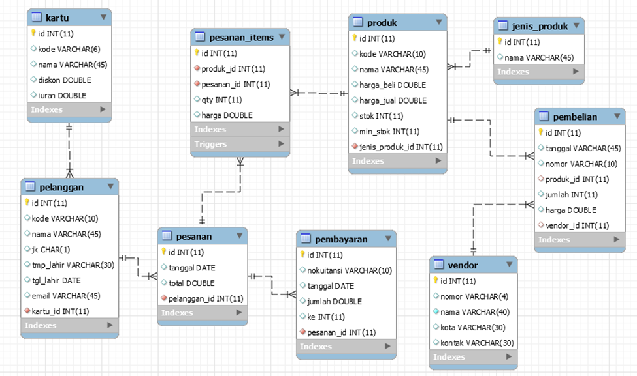

**JAWABAN**

*CREATE TABLE kartu (*

*id integer auto_increment primary key,*

*kode varchar(4) unique,*

*nama varchar(30) not null,*

*diskon double default 0,*

*iuran double default 0*

*);*

INSERT INTO kartu VALUES

("", 'P0001', "VVIP", 0, 2000),

("", 'P0002', "GOLD", 0.1, 3000),

("", 'P0003', "SILVER", 0.3, 40000),

("", 'P0004', "BRONZE", 0.4, 50000),

("", 'P0005', "BRONZE-II", 0.5, 60000)

;

*CREATE TABLE pelanggan(*

*id INT PRIMARY KEY AUTO_INCREMENT,*

*kode varchar(10) unique,*

*nama varchar(45) not null,*

*jk char(1),*

*tmp_lahir varchar(30),*

*tgl_lahir date not null,*

*email varchar(45),*

*kartu_id int,*

*FOREIGN KEY (kartu_id) references kartu (id)*

*);*

INSERT INTO pelanggan VALUES

('', 'P0001', 'Fikri', 'L', 'DKI Jakarta', ‘2012-12-12’, 'fikri@gmail.com', 1),

('', 'P0002', 'Ruid', 'l', 'Serpong', ' 2014-11-10', 'rudi@gmail.com', 2),

('', 'P0002', 'Sinta', 'P', 'Aceh', '2004-06-08', 'sinta@gmail.com', 3)

('', 'P0004', 'Friska', 'P', 'Banten', '2010-04-14', 'friska@gmail.com', 4),

('', 'P0005', 'Son', 'L', 'Bogor', '1991-10-13', 'son@gmail.com', 5);

CREATE TABLE pesanan(

id int primary key auto_increment,

tanggal date,

total double,

pelanggan_id int,

FOREIGN KEY (pelanggan_id) references pelanggan(id)

);

INSERT INTO pesanan VALUES

(default, "2014-12-05", 50000, 1),

(default, "2010-11-07", 30000, 2),

(default, "2009-03-22", 50000, 3),

(default, "2014-02-24", 60000, 4),

(default, "2006-12-04", 84000, 5)

;

CREATE TABLE pesanan_items(

id int primary key auto_increment,

produk_id INT not null,

pesanan_id INT not null,

qty int not null,

harga double,

FOREIGN KEY (produk_id) references produk(id),

FOREIGN KEY (pesanan_id) references pesanan(id)

);

INSERT INTO pesanan_items VALUES

('', 1, 8, 4, 200000),

('', 2, 9, 2, 60000),

('', 3, 10, 3, 150000),

('', 4, 11, 2, 120000),

('', 5, 12, 3, 240000)

;

CREATE TABLE jenis_produk(

id INT PRIMARY KEY auto_increment,

nama varchar(45)

);

INSERT INTO jenis_produk VALUES

('', 'ELEKTRONIK'), ('', 'FOOD'), ('', 'DRINK'), ('', 'FURNITURE'), ('', 'GADGET')

;

CREATE TABLE produk(

id int primary key auto_increment,

kode varchar(10) *unique*,

nama varchar(45),

harga_beli double,

harga_jual double,

stok int,

min_stok int,

jenis_produk_id INT,

FOREIGN KEY (jenis_produk_id) references jenis_produk (id)

);

INSERT INTO produk VALUES

("", "PR001", "Laptop", 30000, 40000, 3, 1, 1),

("", "PR002", "pizza", 250000, 300000, 3, 1, 2),

("", "PR003", "Pop ICE", 150000, 200000, 7, 1, 3),

("", "PR004", "Lemari Pakaian", 550000, 700000, 4, 1, 4),

("", "PR005", "Sony Xperia Xa2", 650000, 800000, 2, 1, 4)

;

CREATE TABLE vendor(

id int primary key auto_increment,

nomor varchar(4),

nama varchar(40),

kota varchar(30),

kontak varchar(30)

);

INSERT INTO vendor VALUES

("", 1, "Azhar", "Jakarta Selatan", "azhar88@gmail.com"),

("", 2, "Renaldi", "Bandung", "Renaldi@gmail.com"),

("", 3, "Figo", "Amsterdam", "lous-figo@gmail.com"),

("", 4, "Fahmi", "Tanggerang", "fahmigmail.com"),

("", 5, "Rasyad", "Bekasi", "rasyadgmail.com")

;

create table pembelian (

id INT PRIMARY KEY AUTO_INCREMENT,

tangggal varchar(45),

nomor varchar(10),

produk_id INT,

jumlah int,

harga double,

vendor_id int,

FOREIGN KEY (produk_id) references produk(id),

FOREIGN KEY (vendor_id) references vendor(id)

);

INSERT INTO pembelian VALUES

("", "2012-12-12", 1, 1, 2, 60000, 1 ),

("", "2010-10-04", 1, 1, 3, 50000, 2 ),

("", "2006-11-03", 1, 1, 3, 50000, 3 ),

("", "2007-05-09", 1, 1, 3, 50000, 4 ),

("", "2015-11-04", 1, 1, 3, 50000, 5 )

;

CREATE TABLE pembayaran (

id INT PRIMARY key auto_increment,

nokuintasi VARCHAR(10),

tanggal date,

jumlah double,

ke int,

pesanan_id INT,

FOREIGN KEY (pesanan_id ) references pesanan(id)

);

INSERT INTO pembayaran VALUES

(DEFAULT, "PE001", "2011-04-04", 12, 1, 8),

(DEFAULT, "PE001", "2005-12-12", 12, 1, 9),

(DEFAULT, "PE001", "2011-03-11", 5, 1, 10),

(DEFAULT, "PE001", "2007-07-12", 4, 1, 11),

(DEFAULT, "PE001", "2012-04-03", 10, 5, 12)

;